## 

horizontal line

**Mono Apartments -**

**Iteration 2 Report v1.0**

April, 2023

—

Prepared for Modern Nomads Group Pty Ltd

For Yudo Baskaro, Director of the company

# **Executive Overview**

* 1. Current Iteration Overview

For the final iteration of the system, our end goal is to bring as much value overall as is within our resources and capabilities. Iteration 1 focused upon the development of the system itself, combining both elements of the admin functionality which played into some basic elements of contractor functionality. The admin functionality enabled viewing of inspection tasks and apartments owned by Mono. This enabled scheduling of inspection tasks as well as viewing an inspection history as well as which user(contractor) had been allocated the task. The admin can also view a list of users which will be particularly of use when managing contractors and which might have access to the system. Email functionality through the system was also developed which will enable the scheduling of jobs to contractors and will be further developed in iteration 2.

In the upcoming Iteration, our focus will be on allowing a mono admin to send through job requests via email that can be accepted or denied by any contractors who are sent through the request. We will also work on providing a complete functional Inspection Form that a contractor can easily complete which will then be accessible to Mono admins in PDF format. Along with the functional requirements of this iteration we will also be looking to provide as many non-functional requirements as possible within our scope, which will involve adding beautification changes to all of our interfaces, the login and the admin/contractor portals.

Previous Deliverables

We have ultimately delivered most of these features as were agreed upon in iteration 1, with more improvements required for inspection task scheduling so that all contractors can be notified of an inspection, which can be accepted or rejected rather than sending an email through the system which the admin needs an email of the contractor and text to fill in the text box. Furthermore, the inspection functionality will need to be broadened to ensure image functionality in the inspection is sufficient, with multiple descriptions being enabled to be added to the system, as was agreed upon but was not able to be delivered to a full extent in iteration 1.

## Iteration 2 Requirements.

Mono Apartments have requested some key requirements and improvements for their desired system:

Priority 1: Further Develop the Admin Functionality for the System.

* To View the inspection form as a pdf/downloadable file for better offline access.
* Inspection and Contractor management system
  + Send inspection to all contractors to allow them to approve/reject a job request
  + Submit queries to contractors in the inspection view to follow up directly and automatically to issues in an inspection.
* Track inspection details tied to each apartment, so each apartment’s inspection history can be viewed.

Priority 2: To develop deeper Contractor functionality

* Inspection view allows better job management.
  + Contractor can more clearly view upcoming tasks that have been assigned to them after accepting.
  + Contractors can view a more detailed list of their inspections that they have completed.

# **Personas**

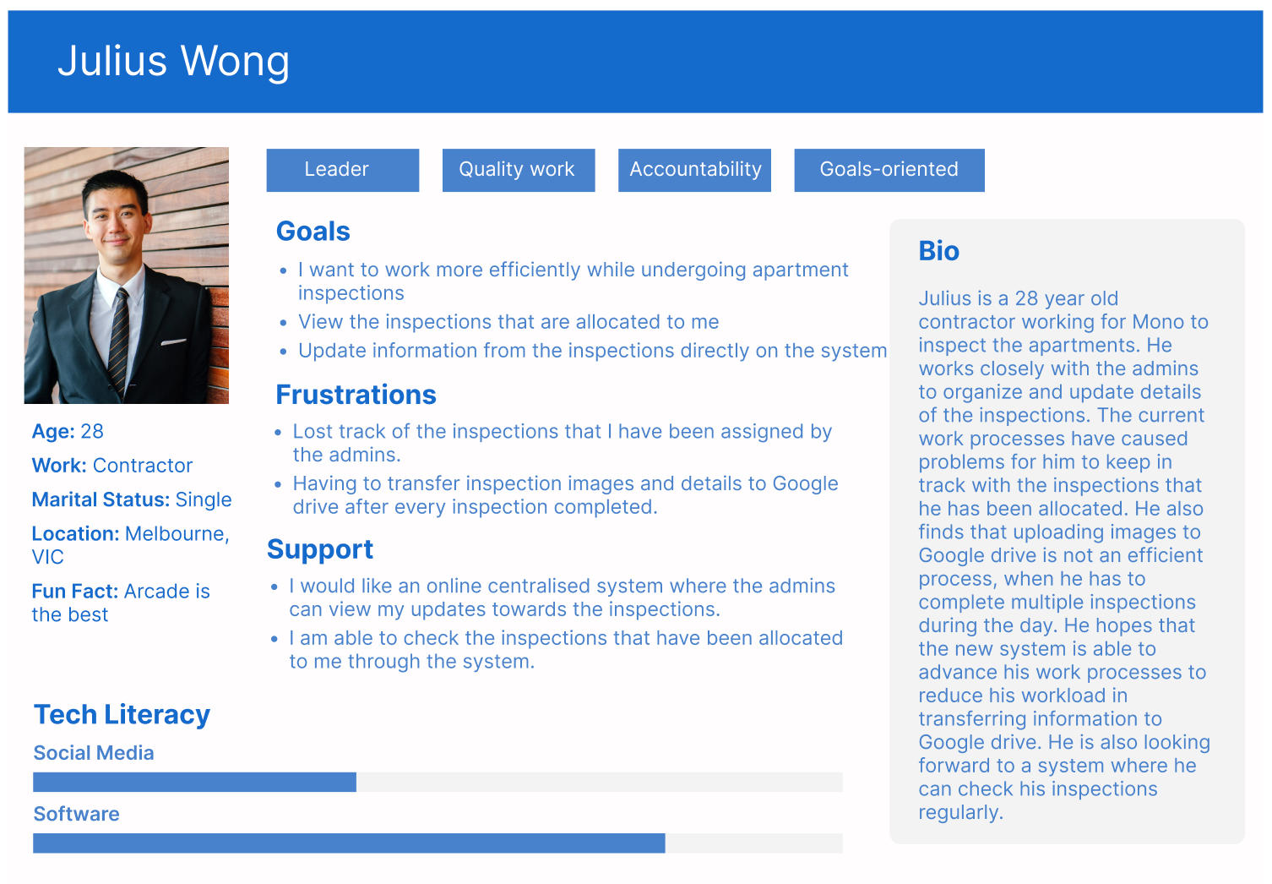

## 

## 

## **Timeline**

## Timeline

## 

| **Meeting** | **Date** | **Participant** |
| --- | --- | --- |
| Iteration 2 Presentation | 09/03/2023 | Client and Team |
| **Iteration 1** | | |
| Iteration 1 goes live | 06/04/2023 | Team |
| **Iteration 2** | | |
| Iteration Report and Presentation | 06/04/2023 | Client and Team |
| Acceptance Testing | 28/04/2023 | Client |
| Iteration goes live | 11/05/2023 | Team |
| Post -Implementation Review | 15/05/2023 | Team |
| **Delivery** | | |
| Handover Training | 11/05/2023 | Client and Team |
| Final Build and Report | 15/05/2023 | Client and Team |
| System Handover Package & Documentation | 17/05/2023 | Team |
| Final Client Acceptance Test | 22/05/2023 | Client |
| Handover Package to Clients and Final Feedback | 25/05/2023 | Client and Team |

## Risks and Considerations

This iteration will propose broader changes to the project and deliver many built in improvements to Iteration 1. Some of the risks will be around handling the data that relates to the inspections, such as the images and inspection descriptions. Considerations need to be made to ensure that all data is handled well and can not be lost or mishandled off the system. Considerations will also need to be made into the time handover of the project, allowing admin staff more than enough time to insert new data into the system before it needs to be used. Risks need to also be considered around the system’s usability to ensure it will work with the target audience. Even as these risks are minimal, the team needs to ensure even limited working prototypes provide usable and tangible benefits to admin staff and contractors alike.

## Updates

Mono explained that they wanted early functionality from iteration 1 to be able to test out with their admin staff prior to iteration 2 was finished so early changes can be adopted. Mono also explained that the inspection form would need time frames for the inspections to be implemented, built off Mono’s internal admin time sheet. Mono also mentioned that they would love a way of tracking which contractor has accepted an inspection.

1. **Client Sign-off**

Instructions:

1. Please review the enclosed material.
2. Please contact the client liaison with any questions or concerns that you may have during your review through email or phone call.
3. You may contact the client liaison to indicate changes at any time during the review.
4. Please send this sign-off document by 16th August 2022 to: (Cassandra, email: pton0008@student.monash.edu).

Approval Signature:

By signing this document, I acknowledge that team OneTen understands my business and requirements at this specific time. I understand that additional changes or prioritisation to the requirements of the content of this report should be informed to the client liaison directly.

Client: __________________________ Name and Date: ________________________

Team client liaison: __________________________ Name and Date: ______________